Statistical Analysis of Effect of COVID-19 among Student Populations Food Habits

Bivariate Analysis on SPSS

Stephanie Lee-Chan

Wilfrid Laurier University

December 23, 2021

A noticeable question has arisen from university students during the COVID-19 pandemic of whether their eating habits have been affected. This study was conducted using the survey method utilizing Qualtrics survey platform and SPSS to suggest a possible answer to this question. The students were given a mix of qualitative and quantitative research questions during the survey prior to the following bivariate analysis and visualizing of statistical data.

Comparing Hours Spent Eating and Hometown  
  
Figure 1

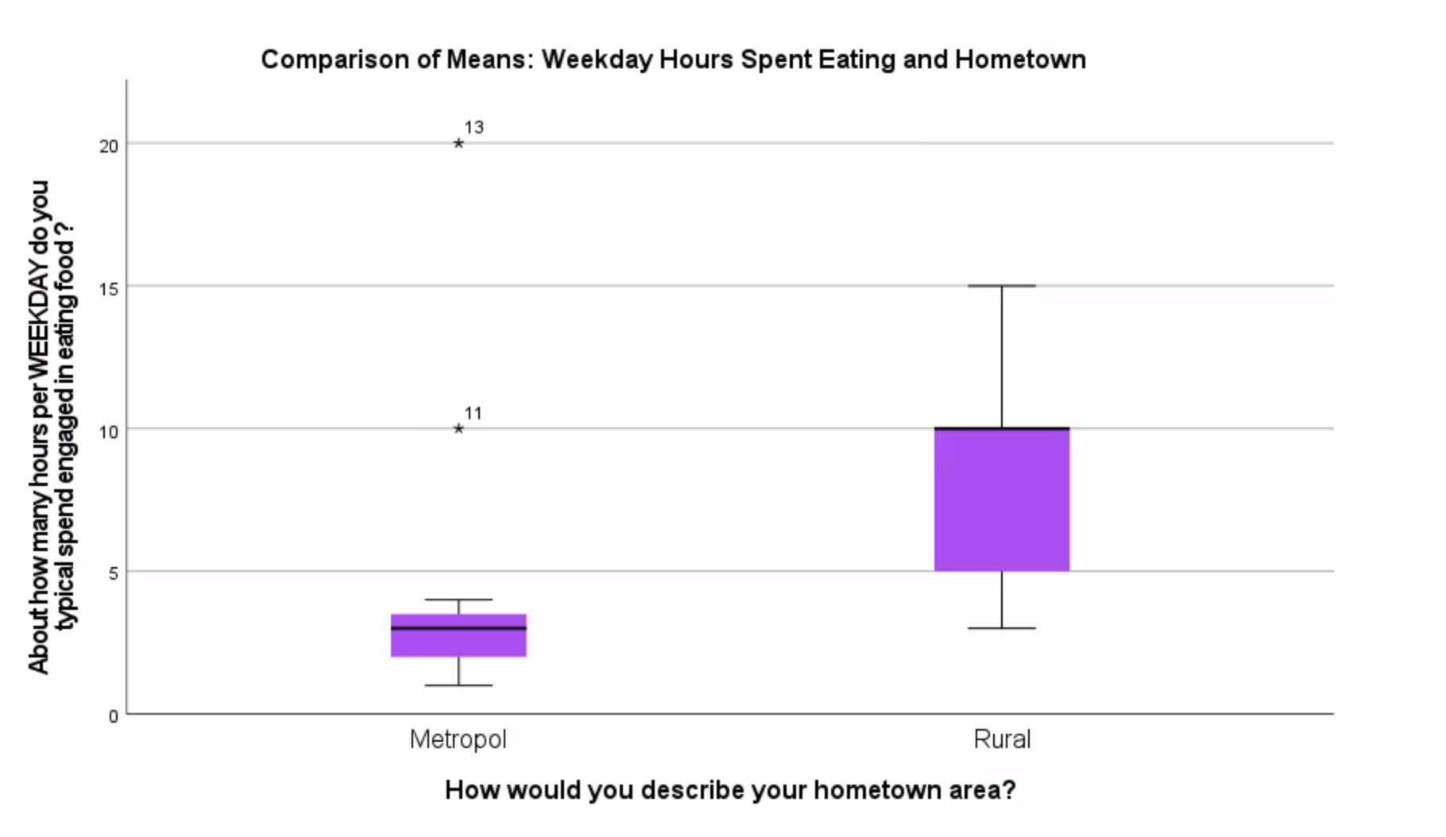

Table 1

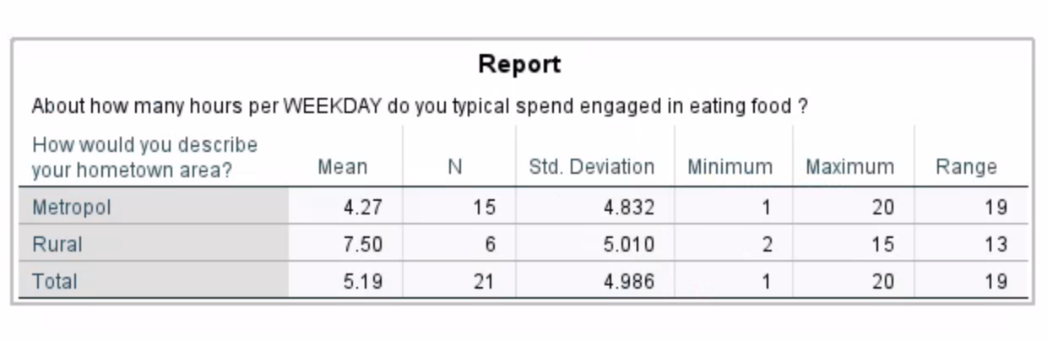

An examination of means with weekday and hometown area is shown in figure #1 and table #1. The result was explored because of interest in eating habits between metropolitan and rural students. The correlation was between weekday and hometown in regard to how much eating is conducted with a sample of students in GESC254 this semester fall 2021. Overall, it appears that the mean for eating during the week is higher in rural area students than the mean for eating in metropolitan area students. Overall, there is a general trend towards metropolitan students being represented in this sample study. Overall, the distribution of students engaged in eating has a lower minimum and higher maximum for metropolitan area students. Notice the difference between the range of 19 for metropolitan area students and 13 for rural students. A clear pattern of less variation among rural students was reported. The majority of metropolitan students fall inside 1 to 5 hours. Two exceptions to this trend are the numbers 11 and 13 shown in Figure 1. This trend holds except for the case where no rural area students reported 1 hour or over 15 hours. Note how the mean for students engaged with eating during the week is 5.19 in total.

This result is somewhat expected given there are 15 metropolitan students represented (as originally suburbs students and downtown students were two separate categories and were merged into simply metropolitan students to create a binary) versus only 6 rural students represented. This trend/pattern/distribution could be due to students in rural areas having longer hours spent eating because of less restaurants in the area versus metropolitan area students having higher numbers of restaurants. This trend/pattern/distribution is similar to common conceptions of students in metropolitan areas having a larger range of understanding their eating habit hours in the weekdays due to public transit or other factors. This trend/pattern/distribution of two major statistical outliers in metropolitan students is in direct contrast to the rural students which had no outliers. It might be interesting to research this further by exploring this relationship with time spent eating by doing studies on the amount of food consumed or what leads students to spend more hours eating. Another interesting research question is comparing suburban students with downtown students.

Comparing Hours Spent Eating and University Program  
Figure 2

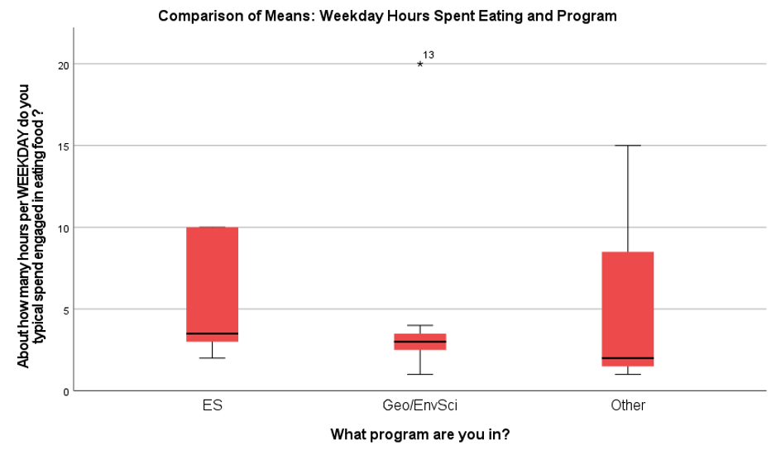

Table 2

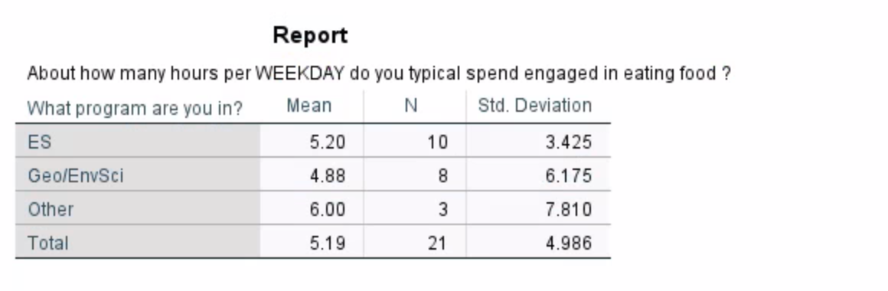

An examination of means with weekday and hometown area is shown in figure #2 and table #2. This result was explored because of an interest in comparing the differences in food consumption among students at different university programs including Environmental Studies, Geography or Environmental Science, and other programs not specified.

Overall, it appears that the average and range between Environmental Studies students and other programs is higher than between Geography or Environmental Science students.

A clear pattern of between 0 and 5 hours is evident for Geography or Environmental Science students. One exception to this trend is the statistical outlier of 13 hours among Geography and Environmental Science students.

This result is somewhat expected given the category other programs encapsulate a lot of students. It might be interesting to research this further by exploring this relationship with food consumption by doing mass university-wide program comparisons rather than just three categories.

Mass Comparison of Statistical Data  
Table 3

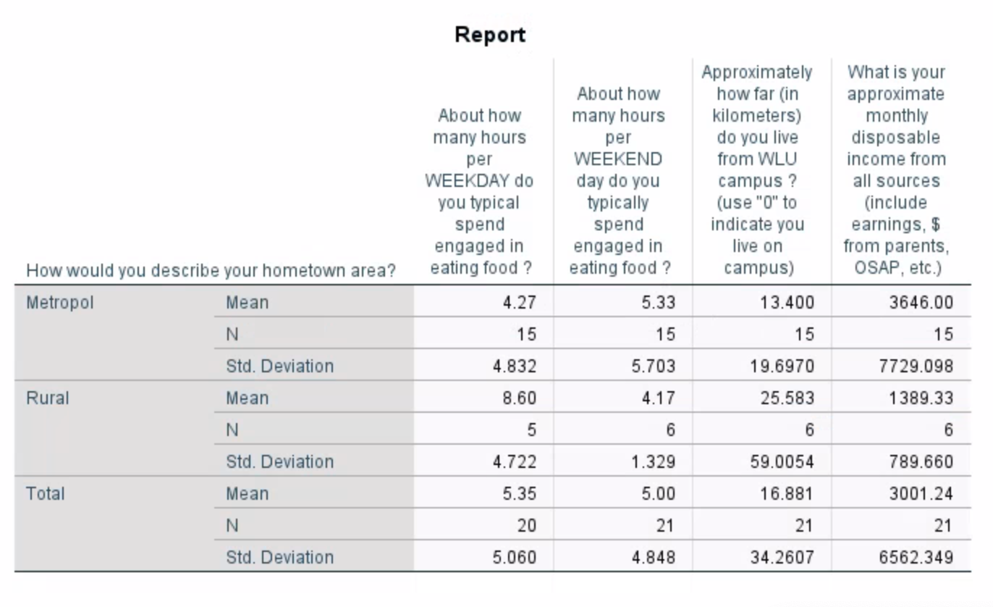

An examination of hours spent per weekday, hours spent per weekend, distance from Wilfrid Laurier University campus, and monthly disposable income in comparison to is shown in table #3. This result was explored because of all the potential factors that would influence eating habits.

Overall, it appears that the monthly disposable income with metropolitan students is higher than with rural students. Overall, a general trend towards eating more hours on weekdays than weekends is evident among rural students and the opposite situation among metropolitan students.

It might be interesting to research this further by exploring this relationship with eating habits, income, and distance from campus by doing analysis of how those play a role in the types of food consumed and length of time eating takes a student.

Continuous Variables with Correlation Coefficients (R2)   
Table 4

|  |  |  |  |  |  |  |  |  |  |
| --- | --- | --- | --- | --- | --- | --- | --- | --- | --- |
| Correlations | | | | | | | | | |
|  | | About how many hours per WEEKDAY do you typical spend engaged in eating food? | About how many hours per WEEKEND day do you typically spend engaged in eating food? | Rate your agreement with the following statements concerning your eating habits: - This is one of my favorite activities | Rate your agreement with the following statements concerning your eating habits: - I wish I could spend more time on this activity | Rate your agreement with the following statements concerning your eating habits: - This activity is good for my overall health | Rate your agreement with the following statements concerning your eating habits: - Covid-19 has affected this activity | Approximately how far (in kilometers) do you live from WLU campus? (use "0" to indicate you live on campus) | What is your approximate monthly disposable income from all sources (include earnings, $ from parents, OSAP, etc.) |
| About how many hours per WEEKDAY do you typical spend engaged in eating food? | Pearson Correlation | 1 | .763** | -.015 | .144 | -.066 | -.158 | -.235 | -.111 |
| Sig. (2-tailed) |  | <.001 | .951 | .556 | .783 | .506 | .319 | .641 |
| N | 20 | 20 | 20 | 19 | 20 | 20 | 20 | 20 |
| About how many hours per WEEKEND day do you typically spend engaged in eating food? | Pearson Correlation | .763** | 1 | .069 | .324 | .162 | .079 | -.189 | -.032 |
| Sig. (2-tailed) | <.001 |  | .766 | .163 | .483 | .734 | .411 | .890 |
| N | 20 | 21 | 21 | 20 | 21 | 21 | 21 | 21 |
| Rate your agreement with the following statements concerning your eating habits: - This is one of my favorite activities | Pearson Correlation | -.015 | .069 | 1 | .725** | .495* | .475* | -.053 | .225 |
| Sig. (2-tailed) | .951 | .766 |  | <.001 | .023 | .030 | .821 | .327 |
| N | 20 | 21 | 21 | 20 | 21 | 21 | 21 | 21 |
| Rate your agreement with the following statements concerning your eating habits: - I wish I could spend more time on this activity | Pearson Correlation | .144 | .324 | .725** | 1 | .192 | .357 | -.299 | .290 |
| Sig. (2-tailed) | .556 | .163 | <.001 |  | .418 | .122 | .200 | .214 |
| N | 19 | 20 | 20 | 20 | 20 | 20 | 20 | 20 |
| Rate your agreement with the following statements concerning your eating habits: - This activity is good for my overall health | Pearson Correlation | -.066 | .162 | .495* | .192 | 1 | .405 | .124 | -.008 |
| Sig. (2-tailed) | .783 | .483 | .023 | .418 |  | .069 | .592 | .973 |
| N | 20 | 21 | 21 | 20 | 21 | 21 | 21 | 21 |
| Rate your agreement with the following statements concerning your eating habits: - Covid-19 has affected this activity | Pearson Correlation | -.158 | .079 | .475* | .357 | .405 | 1 | -.342 | .287 |
| Sig. (2-tailed) | .506 | .734 | .030 | .122 | .069 |  | .129 | .208 |
| N | 20 | 21 | 21 | 20 | 21 | 21 | 21 | 21 |
| Approximately how far (in kilometers) do you live from WLU campus? (use "0" to indicate you live on campus) | Pearson Correlation | -.235 | -.189 | -.053 | -.299 | .124 | -.342 | 1 | -.068 |
| Sig. (2-tailed) | .319 | .411 | .821 | .200 | .592 | .129 |  | .771 |
| N | 20 | 21 | 21 | 20 | 21 | 21 | 21 | 21 |
| What is your approximate monthly disposable income from all sources (include earnings, $ from parents, OSAP, etc.) | Pearson Correlation | -.111 | -.032 | .225 | .290 | -.008 | .287 | -.068 | 1 |
| Sig. (2-tailed) | .641 | .890 | .327 | .214 | .973 | .208 | .771 |  |
| N | 20 | 21 | 21 | 20 | 21 | 21 | 21 | 21 |
| **. Correlation is significant at the 0.01 level (2-tailed). | | | | | | | | | |
| *. Correlation is significant at the 0.05 level (2-tailed). | | | | | | | | | |

An examination of correlations among hours spent on eating during weekdays and weekends, distance from Wilfrid Laurier University campus, monthly disposable income in comparison, agreement which eating because one of their favourite hobbies, wishing they could spend more time on the activity, belief eating is healthy, and effect of COVID-19 is shown in table #4. This result was explored because it is of interest to mass compare all these different factors to use if any were statistically significant correlations to extrapolate further data.

Overall, the distribution of significant correlations appears to mainly cover the agreement categories which includes the following categories: Covid-19 has affected this activity, this activity is good for my overall health, I wish I could spend more time on this activity, and this is one of my favourite activities.

It might be interesting to research this further by exploring this relationship with food consumption being good for overall health and how Covid-19 has affected this activity by studying if students have been sick during this period of time.

COVID-19's Effects on Enjoyment of Food  
Figure 3

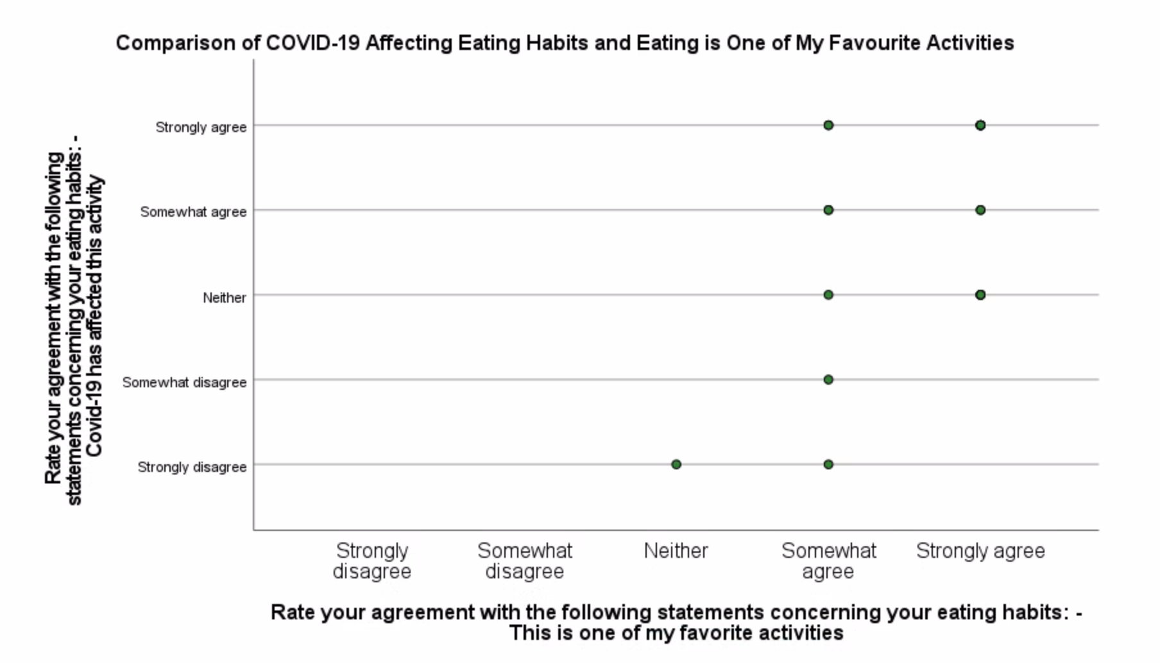

Figure 4

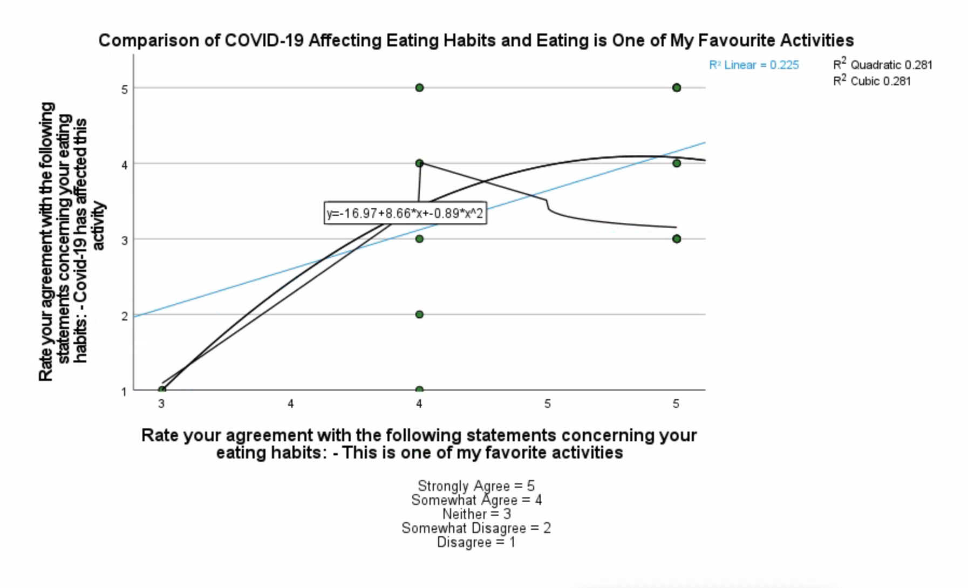

An examination of Covid-19 affecting eating habits and eating as a favourite activity is shown in figure #3 and figure #4. This result was explored because it is a statistically significant correlation and there is a clear correlation and relationship between people who like food consumption and how Covid-19 has affected eating for them in their daily life.

Notice a strong trend towards eating as a favourite activity being strongly agree increases Covid-19 affecting this activity increases as well. Overall, a general trend towards somewhat agree is evident.

This result is somewhat expected given people typically enjoy eating a fair amount except the one person who responded neither to eating being a favourite activity and whether Covid-19 affected this activity. It might be interesting to research this further by exploring this relationship with food by doing studies on types of food consumed and whether the types of food have been affected by Covid-19.

A Comparison of University Program and Hometown

Table 5

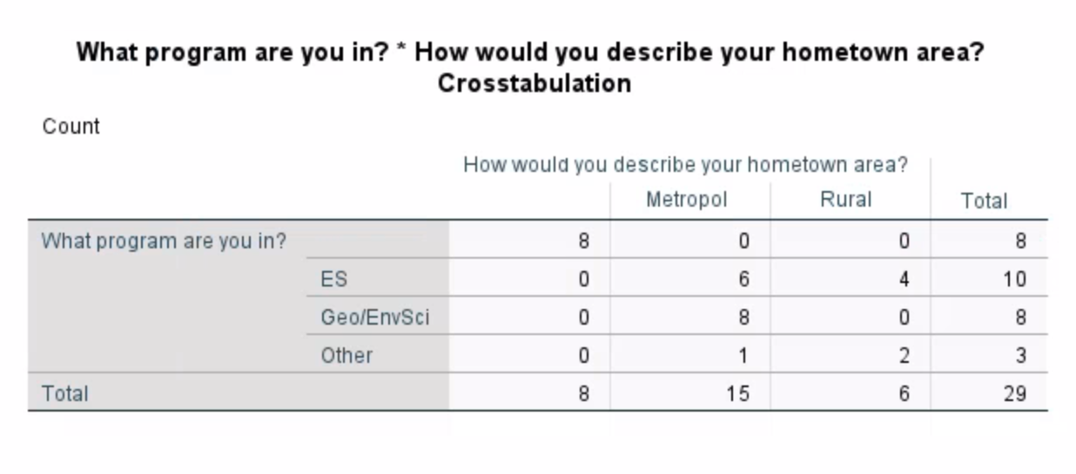

An examination of the program and student is enrolled in, and hometown is shown in table #5. This result was explored because of interest in whether living somewhere rural or metropolitan prior enrolling in university has an effect on eating habits.

Overall, the distribution of Geography or Environmental Science students appears to completely be metropolitan and zero rural. Notice a modest trend towards Geography or Environmental Science as metropolitan increases. The other category has 2 rural and 1 metropolitan.

This result is somewhat expected given there is a higher number of environmental studies students sampled in comparison to Geography or Environmental Science students and only three for other programs. It might be interesting to research this further by exploring this relationship with hometown by doing analysis on what type of hometown affects your university major.

Syntax File

* Encoding: UTF-8.

* Step A: Comparison of means: Weekday hours spent eating and hometown

MEANS TABLES=Weekday BY Hometown

/CELLS=MEAN COUNT STDDEV MIN MAX RANGE.

* Chart Builder.

GGRAPH

/GRAPHDATASET NAME="graphdataset" VARIABLES=Hometown Weekday MISSING=LISTWISE REPORTMISSING=NO

/GRAPHSPEC SOURCE=INLINE

/COLORCYCLE COLOR1(171,73,243), COLOR2(0,93,93), COLOR3(159,24,83), COLOR4(250,77,86),

COLOR5(87,4,8), COLOR6(25,128,56), COLOR7(0,45,156), COLOR8(238,83,139), COLOR9(178,134,0),

COLOR10(0,157,154), COLOR11(1,39,73), COLOR12(138,56,0), COLOR13(165,110,255),

COLOR14(236,230,208), COLOR15(69,70,71), COLOR16(92,202,136), COLOR17(208,83,52),

COLOR18(204,127,228), COLOR19(225,188,29), COLOR20(237,75,75), COLOR21(28,205,205),

COLOR22(92,113,72), COLOR23(225,139,14), COLOR24(9,38,114), COLOR25(90,100,94), COLOR26(155,0,0),

COLOR27(207,172,227), COLOR28(150,145,145), COLOR29(63,235,124), COLOR30(105,41,196)

/FRAME OUTER=NO INNER=NO

/GRIDLINES XAXIS=NO YAXIS=YES

/STYLE GRADIENT=NO.

BEGIN GPL

SOURCE: s=userSource(id("graphdataset"))

DATA: Hometown=col(source(s), name("Hometown"), unit.category())

DATA: Weekday=col(source(s), name("Weekday"))

DATA: id=col(source(s), name("$CASENUM"), unit.category())

GUIDE: axis(dim(1), label("How would you describe your hometown area?"))

GUIDE: axis(dim(2), label("About how many hours per WEEKDAY do you typical spend engaged in ",

"eating food ?"))

GUIDE: text.title(label("Comparison of Means: Weekday Hours Spent Eating and Hometown"))

SCALE: linear(dim(2), include(0))

ELEMENT: schema(position(bin.quantile.letter(Hometown*Weekday)), label(id))

END GPL.

* Encoding: UTF-8.

* Step B: Comparison of means: Weekday hours spent eating and program.

MEANS TABLES=Weekday BY Program

/CELLS=MEAN COUNT STDDEV.

* Chart Builder.

GGRAPH

/GRAPHDATASET NAME="graphdataset" VARIABLES=Program Weekday MISSING=LISTWISE REPORTMISSING=NO

/GRAPHSPEC SOURCE=INLINE

/COLORCYCLE COLOR1(237,75,75), COLOR2(204,134,63), COLOR3(159,24,83), COLOR4(250,77,86),

COLOR5(87,4,8), COLOR6(25,128,56), COLOR7(0,45,156), COLOR8(238,83,139), COLOR9(178,134,0),

COLOR10(0,157,154), COLOR11(1,39,73), COLOR12(138,56,0), COLOR13(165,110,255),

COLOR14(236,230,208), COLOR15(69,70,71), COLOR16(92,202,136), COLOR17(208,83,52),

COLOR18(204,127,228), COLOR19(225,188,29), COLOR20(237,75,75), COLOR21(28,205,205),

COLOR22(92,113,72), COLOR23(225,139,14), COLOR24(9,38,114), COLOR25(90,100,94), COLOR26(155,0,0),

COLOR27(207,172,227), COLOR28(150,145,145), COLOR29(63,235,124), COLOR30(105,41,196)

/FRAME OUTER=NO INNER=NO

/GRIDLINES XAXIS=NO YAXIS=YES

/STYLE GRADIENT=NO.

BEGIN GPL

SOURCE: s=userSource(id("graphdataset"))

DATA: Program=col(source(s), name("Program"), unit.category())

DATA: Weekday=col(source(s), name("Weekday"))

DATA: id=col(source(s), name("$CASENUM"), unit.category())

GUIDE: axis(dim(1), label("What program are you in?"))

GUIDE: axis(dim(2), label("About how many hours per WEEKDAY do you typical spend engaged in ",

"eating food ?"))

GUIDE: text.title(label("Comparison of Means: Weekday Hours Spent Eating and Program"))

SCALE: linear(dim(2), include(0))

ELEMENT: schema(position(bin.quantile.letter(Program*Weekday)), label(id))

END GPL.

* Encoding: UTF-8.

* Step C: Comparison of Four Agreement Scale Variables - Weekday hours spent eating, weekend hours spent eating, Distance from WLU campus, monthly disposable income - and hometown

MEANS TABLES=Weekday Weekend Distance Income BY Hometown

/CELLS=MEAN COUNT STDDEV.

* Encoding: UTF-8.

* Step D: Correlation Table

CORRELATIONS

/VARIABLES=Weekday Weekend Agreement_1 Agreement_2 Agreement_4 Agreement_3 Distance Income

/PRINT=TWOTAIL NOSIG FULL

/MISSING=PAIRWISE.

* Encoding: UTF-8.

* Step E: Scatterplot and Line of Best Fit

* Chart Builder.

GGRAPH

/GRAPHDATASET NAME="graphdataset" VARIABLES=Agreement_1 Agreement_3 MISSING=LISTWISE

REPORTMISSING=NO

/GRAPHSPEC SOURCE=INLINE

/COLORCYCLE COLOR1(41,134,38), COLOR2(0,93,93), COLOR3(159,24,83), COLOR4(250,77,86),

COLOR5(87,4,8), COLOR6(25,128,56), COLOR7(0,45,156), COLOR8(238,83,139), COLOR9(178,134,0),

COLOR10(0,157,154), COLOR11(1,39,73), COLOR12(138,56,0), COLOR13(165,110,255),

COLOR14(236,230,208), COLOR15(69,70,71), COLOR16(92,202,136), COLOR17(208,83,52),

COLOR18(204,127,228), COLOR19(225,188,29), COLOR20(237,75,75), COLOR21(28,205,205),

COLOR22(92,113,72), COLOR23(225,139,14), COLOR24(9,38,114), COLOR25(90,100,94), COLOR26(155,0,0),

COLOR27(207,172,227), COLOR28(150,145,145), COLOR29(63,235,124), COLOR30(105,41,196)

/FRAME OUTER=NO INNER=NO

/GRIDLINES XAXIS=NO YAXIS=YES

/STYLE GRADIENT=NO.

BEGIN GPL

SOURCE: s=userSource(id("graphdataset"))

DATA: Agreement_1=col(source(s), name("Agreement_1"), unit.category())

DATA: Agreement_3=col(source(s), name("Agreement_3"), unit.category())

GUIDE: axis(dim(1), label("Rate your agreement with the following statements concerning your ",

"eating habits: - This is one of my favorite activities"))

GUIDE: axis(dim(2), label("Rate your agreement with the following statements concerning your ",

"eating habits: - Covid-19 has affected this activity"))

GUIDE: text.title(label("Comparison of COVID-19 Affecting Eating Habits and Eating is One of ",

"My Favourite Activities"))

SCALE: cat(dim(1), include("1", "2", "3", "4", "5"))

SCALE: cat(dim(2), include("1", "2", "3", "4", "5"))

ELEMENT: point(position(Agreement_1*Agreement_3))

END GPL.

* Chart Builder.

GGRAPH

/GRAPHDATASET NAME="graphdataset" VARIABLES=Agreement_1 Agreement_3 MISSING=LISTWISE

REPORTMISSING=NO

/GRAPHSPEC SOURCE=INLINE

/FITLINE TOTAL=YES

/COLORCYCLE COLOR1(41,134,38), COLOR2(0,93,93), COLOR3(159,24,83), COLOR4(250,77,86),

COLOR5(87,4,8), COLOR6(25,128,56), COLOR7(0,45,156), COLOR8(238,83,139), COLOR9(178,134,0),

COLOR10(0,157,154), COLOR11(1,39,73), COLOR12(138,56,0), COLOR13(165,110,255),

COLOR14(236,230,208), COLOR15(69,70,71), COLOR16(92,202,136), COLOR17(208,83,52),

COLOR18(204,127,228), COLOR19(225,188,29), COLOR20(237,75,75), COLOR21(28,205,205),

COLOR22(92,113,72), COLOR23(225,139,14), COLOR24(9,38,114), COLOR25(90,100,94), COLOR26(155,0,0),

COLOR27(207,172,227), COLOR28(150,145,145), COLOR29(63,235,124), COLOR30(105,41,196)

/FRAME OUTER=NO INNER=NO

/GRIDLINES XAXIS=NO YAXIS=YES

/STYLE GRADIENT=NO.

BEGIN GPL

SOURCE: s=userSource(id("graphdataset"))

DATA: Agreement_1=col(source(s), name("Agreement_1"))

DATA: Agreement_3=col(source(s), name("Agreement_3"))

GUIDE: axis(dim(1), label("Rate your agreement with the following statements concerning your ",

"eating habits: - This is one of my favorite activities"))

GUIDE: axis(dim(2), label("Rate your agreement with the following statements concerning your ",

"eating habits: - Covid-19 has affected this activity"))

GUIDE: text.title(label("Comparison of COVID-19 Affecting Eating Habits and Eating is One of ",

"My Favourite Activities"))

GUIDE: text.footnote(label("Strongly Agree = 5\nSomewhat Agree = 4\nNeither = 3\nSomewhat ",

"Disagree = 2\nDisagree = 1"))

ELEMENT: point(position(Agreement_1*Agreement_3))

END GPL.

* Encoding: UTF-8.

* Step F: Cross-tabulated Tables

CROSSTABS

/TABLES=Program BY Hometown

/FORMAT=AVALUE TABLES

/CELLS=COUNT

/COUNT ROUND CELL.

Reference

Lee-Chan, Stephanie. 2021. “COVID-19 and food consumption among   
 student populations. Wilfrid Laurier University.